**Grove - Sound Sensor**

窗体顶端

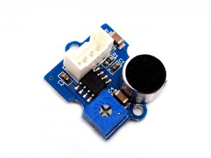

http://www.seeedstudio.com/depot/includes/templates/pure_green/images/next_l.gif

* [http://www.seeedstudio.com/depot/bmz_cache/a/ac2c45f0ab2880dd0898081a977358ba.image.55x41.jpg](http://www.seeedstudio.com/depot/images/P2100722.jpg)
* [http://www.seeedstudio.com/depot/bmz_cache/d/dd32c8b220e01eb4c0d3ce1dbaaf7857.image.55x41.jpg](http://www.seeedstudio.com/depot/images/P2100722_01.jpg)

http://www.seeedstudio.com/depot/includes/templates/pure_green/images/next_r.gif

* **Price:**

$4.90  [(Price Feedback)](javascript:void())

* **SKU:**

SEN12945P

* **Weight:**

5Gram

* **Units in Stock**

37

* **Designed by:**

[Seeed Studio](http://www.seeedstudio.com/)



[Other products from designer](http://www.seeedstudio.com/depot/seeed-studio-m-23.html)

* **Quantity:** Max: 37  
  
* [Add to Wish List](http://www.seeedstudio.com/depot/index.php?main_page=un_wishlist&products_id=752&cPath=144_148&action=un_add_wishlist)

Description

The Sound sensor module is a simple microphone. Based on the power amplifier LM386 and the electret microphone, it can be used to detect the sound strength of the environment. The value of output can be adjusted by the potentiometer.

**Features**

* Grove compatible interface
* Wide supply voltage range: 4V-12V
* Low quiescent current drain: 4mA
* 2.0cm x 2.0cm twig module
* Minimum external parts
* Gain adjustable

**Applications Ideas**

* Simple microphone
* Sound detection

**Documents**

Please visit our [wiki page](http://garden.seeedstudio.com/index.php?title=Twig_-_Sound_Sensor) for more info about this product. It will be appreciated if you can help us improve the documents, add more demo code or tutorials. For technical support, please post your questions to our [forum](http://www.seeedstudio.com/forum).

窗体底端